Project Name: Green Bus (Bus Booking Application)

Date: 5th Jan 2023

Copyright Notice
This document contains proprietary information of HCL Technologies Ltd. No part of this document may be reproduced, stored, copied, or transmitted in any form or by means of electronic, mechanical, photocopying or otherwise, without the express consent of HCL Technologies. This document is intended for internal circulation only and not meant for external distribution.

Revision History
Version No | Date | Prepared by / Modified by | Significant Changes
1.0 | 5th Jan 2023 | A Mukilan | Database
1.0 | 5th Jan 2023 | Nirmal | Bus Details
1.0 | 5th Jan 2023 | Chepa Jayanth | Booking Details
1.0 | 5th Jan 2023 | Hemanth | Payment
1.0 | 5th Jan 2023 | Vishnu Teja | Welcome, Confirmation, Exit

Table Of Contents

1.1 Project Overview 3
1.2 Scope 3
1.3 Out of Scope 3
1.4 Intended Audience 3
1.5 High Level Use Cases 3
1.6 Use Cases detailed 3
1.7 User Interface Modules 3
1.8 Technical Architecture 3
1.9 Technical Detailed Description 3
1.10 Sequence Diagram 3
1.11 Database Entity Relationship Diagram 3
1.12 Standards 3
1.13 Non Functional Requirements 3

Project Overview

Scope

Out of Scope

Intended Audience

High Level Use Cases

Use Cases detailed

User Interface Modules

Technical Architecture

Technical Detailed Description

Sequence Diagram

Database Entity Relationship Diagram

Standards

Non Functional Requirements

  - Project Overview: - This project developing an application which helps the passengers to book bus tickets from different cities on different dates. Passengers will have an option to choose between AC & Non-AC classes and they can make the payment online as well as using cash according to their convenience.

1.2 Scope: The reservation system helps the customer to enquire the availability of seats in a particular bus at particular date, and even the class of the bus. The application allows to reserve a ticket and the payment can be done in cash can be paid using Card and UPI also for the ease of customer. After completion of payment customer gets the display of confirmation message.

Modules | Roles and application | Description
Welcome | Admin & User | Welcome message is displayed and user is asked to Book tickets or Exit
Bus Details | Admin | Bus details are displayed
Booking Details | User | User need to give passenger details
Payment | User | User need to make the payment
Confirmation | Admin | Admin displays confirmation message after payment
Exit | User | User can exit

1.3 Out of Scope: -

These features are not to be tested because they are not included in the Software Requirement Specification.

- User interface
- Hardware Interface
- Software Interface

1.4 Intended Audience: -
The document is intended for all the stakeholders customer and the developer (designers, testers,
maintainers). The reader is assumed to have basic knowledge of banking accounts and account
services. Knowledge and understanding of UML diagrams is also require
The document is intended for all the stakeholders customer and the developer (designers, testers,
maintainers). The reader is assumed to have basic knowledge of banking accounts and account
services. Knowledge and understanding of UML diagrams is also require
- Admin
- User
The document is intended for all the stakeholders customer and the developer (designers, testers,
maintainers). The reader is assumed to have basic knowledge of banking accounts and account
services. Knowledge and understanding of UML diagrams is also require
The document is intended for all the stakeholders customer and the developer (designers, testers,
maintainers). The reader is assumed to have basic knowledge of banking accounts and account
services. Knowledge and understanding of UML diagrams is also require
In this Bus Booking Application, it is open to all users and they can book a bus ticket by giving valid details. The aim is to book the bus ticket based on ‘From City’ and ‘To City’ and the class of bus and on particular dates and make the payment online for hassle free boarding. Basically, the project describes on for booking the bus tickets.

1.5 High Level Use Cases: -

1. Welcome Module
* String book
* String exit

2. Bus Details
* Integer Bus no
* String From City
* String To City
* String Bus Type
* Time Time
* Integer Bus Capacity
* Integer Fare

3. Booking details
* String Name
* Integer Bus No
* Date Date
* Long Mobile No
* String Email

4. Payment
4.1 Credit Card
* Long Card Number
* String Expiry date
* Integer CVV
* String Name

4.2 UPI
* String UPI ID

5. Confirmation

6. Exit
* Integer exit

1.6 Use Cases detailed: -

1. Welcome
This use case describes to continue for booking after the welcome message.

2. Bus Display
This use case describes the busses available for the passenger to book based on source city, destination, class and price.

3. Booking Details
This use case describes that the user need to give his/her name, bus number, date, mobile number and email address.

4. Payment
This use case describes how the passenger can make payment using Card and UPI online or Cash (at the time of boarding).

5. Confirmation
This use case describes the confirmation message for the passenger after he/she make the payment.

6. Exit
This use case describes that the user can exit; after booking a ‘Thank you’ message will be displayed.

1.7 User Interface Modules: - The Bus Booking Application user interface has a console display, which shows the bus details to the users. Users are asked to enter their details for booking the bus ticket.

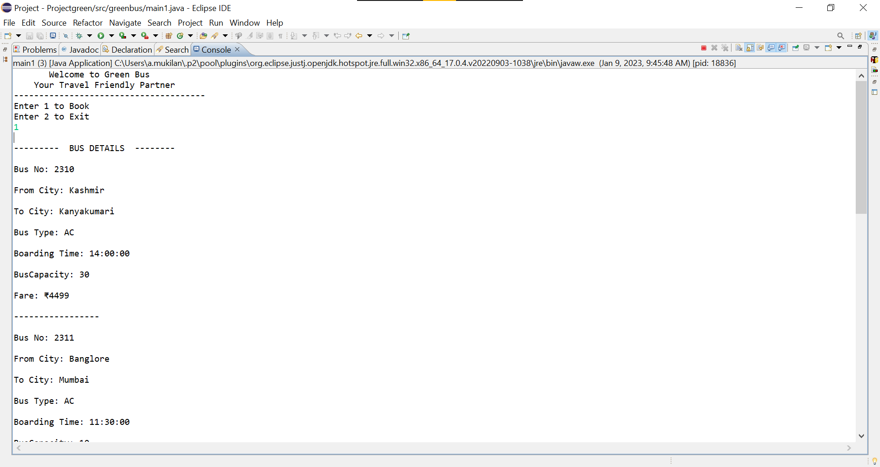

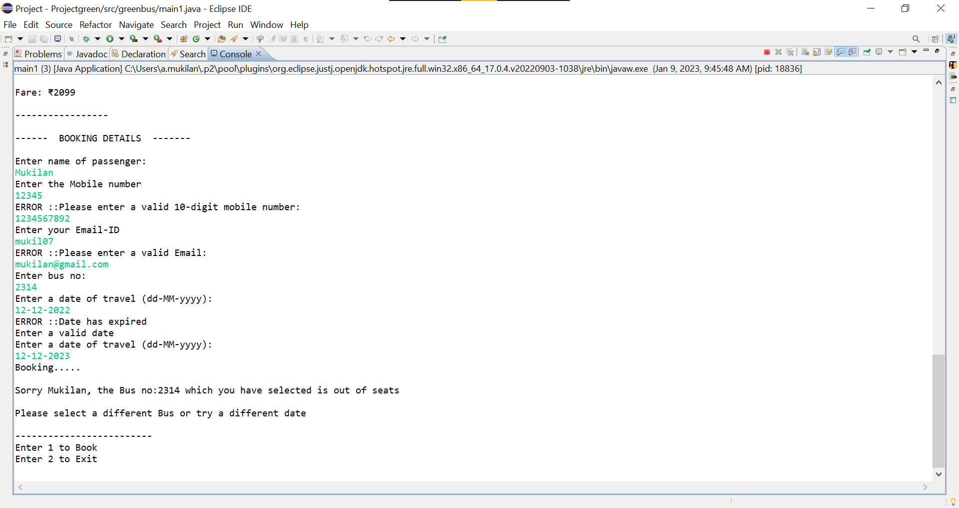
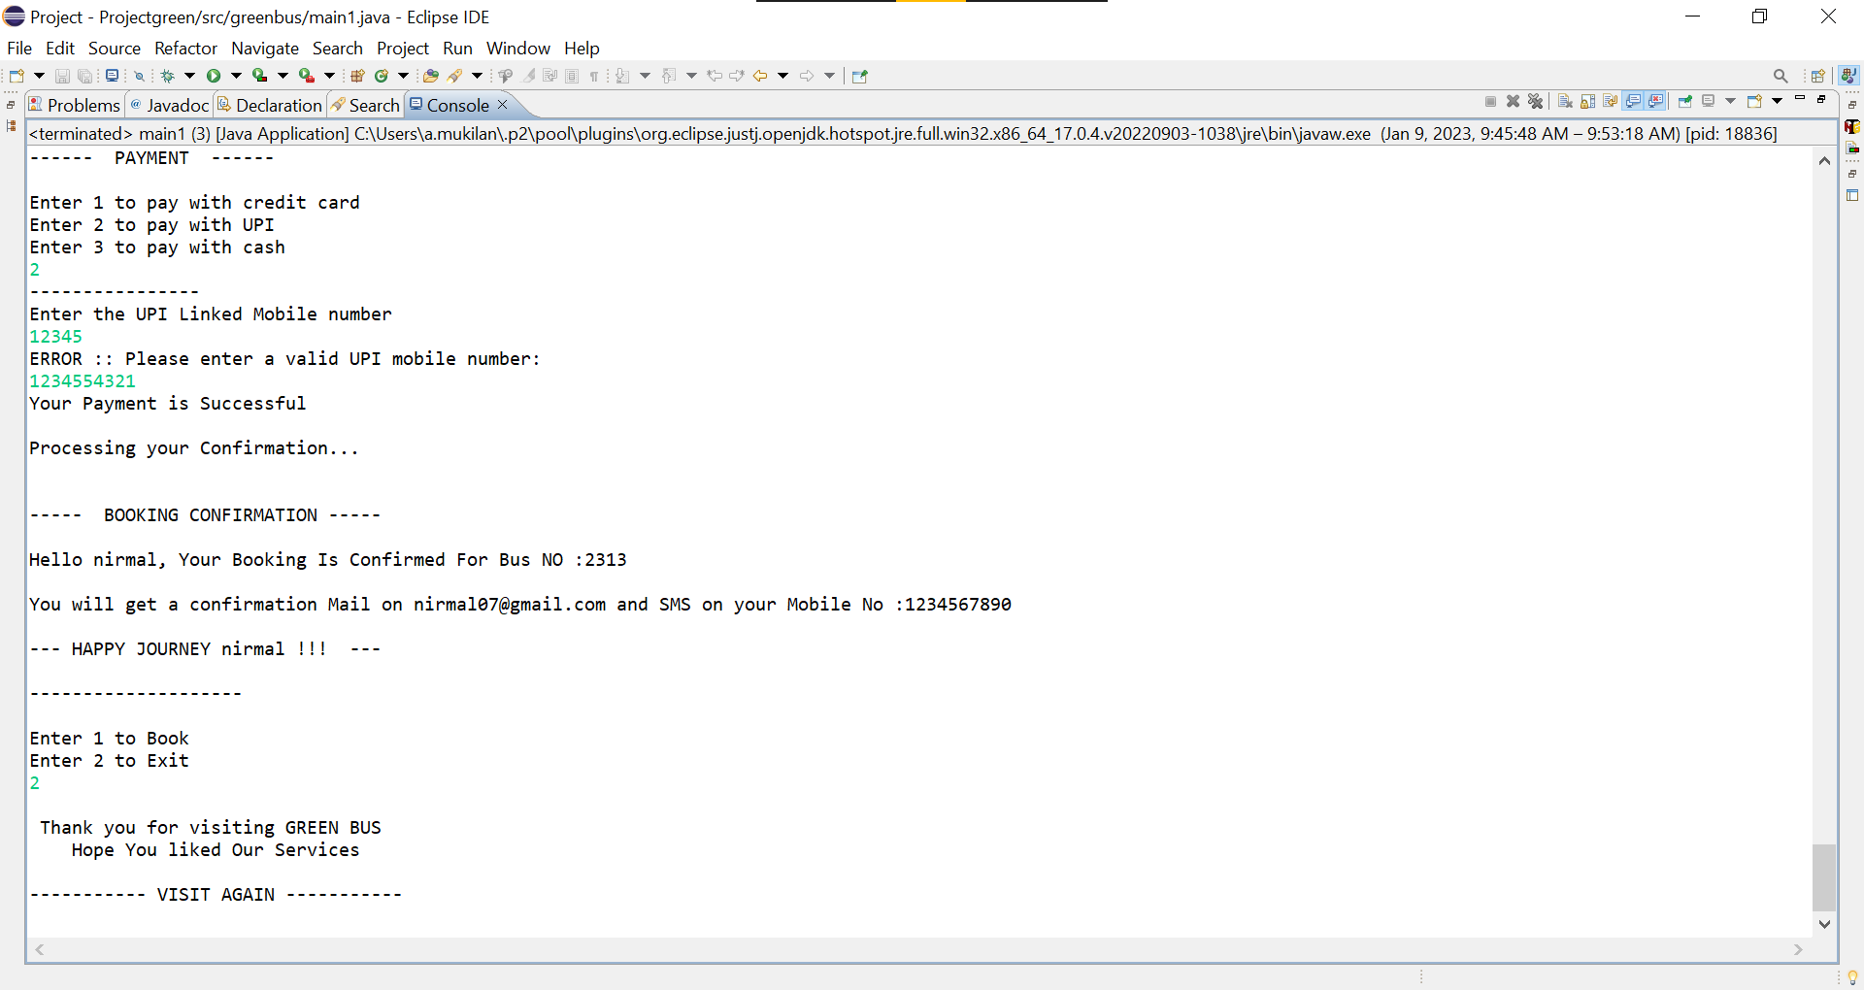

1.8 Technical Architecture: -

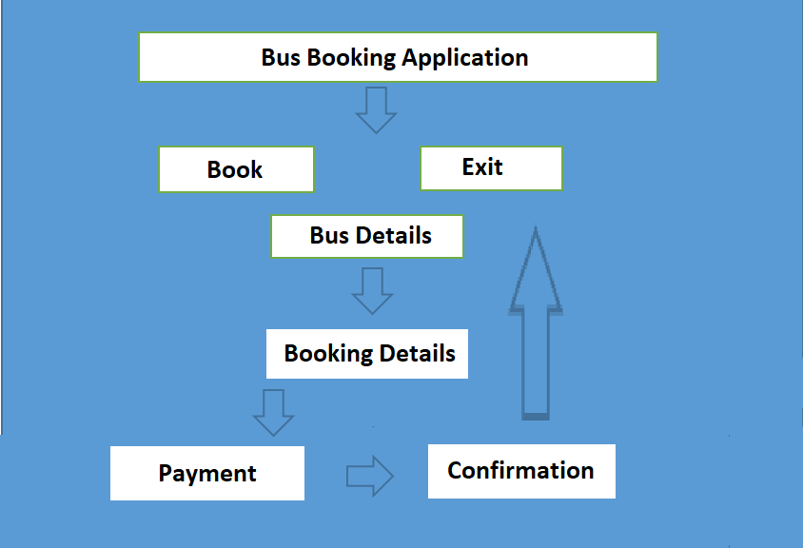

1.9 Technical Detailed Description: -

In the Bus Booking console application, we have included Welcome, Bus details, Booking details, Payment, Confirmation and Exit modules.

Welcome:
In this module a welcome message is displayed to the user and is asked to click 1 to book and 2 to exit.

Bus Details:
In this module we are displaying multiple buses from different locations with different classes so that the user can choose any of the bus which they want to book for by busing the bus number provided here.

Booking Details:
In this module we would be requiring the user to give input details like his/her name, bus number, date, mobile number and email address.

Payment:
In this module the user needs to make the payment using Card, UPI or Cash (at the time of boarding).

Confirmation Details:
In this module the admin displays a confirmation message to the user displaying their name with the mobile number and Email to which they will get a confirmation mail with the other details.

1.10 Sequence Diagram: -

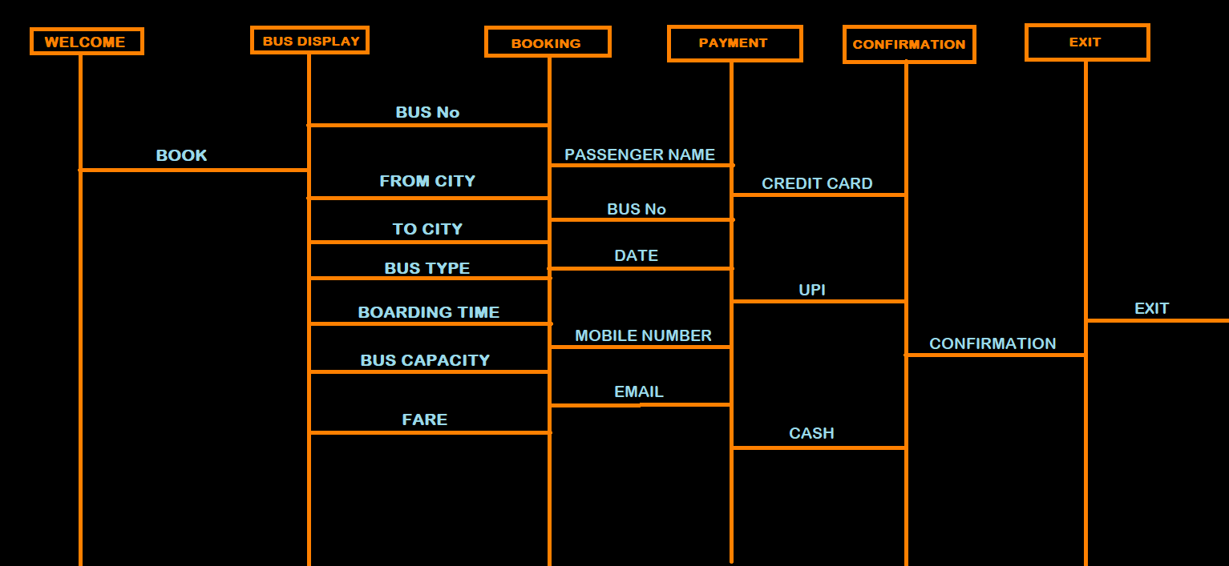

1.11 Database Entity Relationship Diagram: - The diagram for Bus Booking Application shows the relationships between the modules. This ER diagram is done by identifying the steps followed while giving the input.

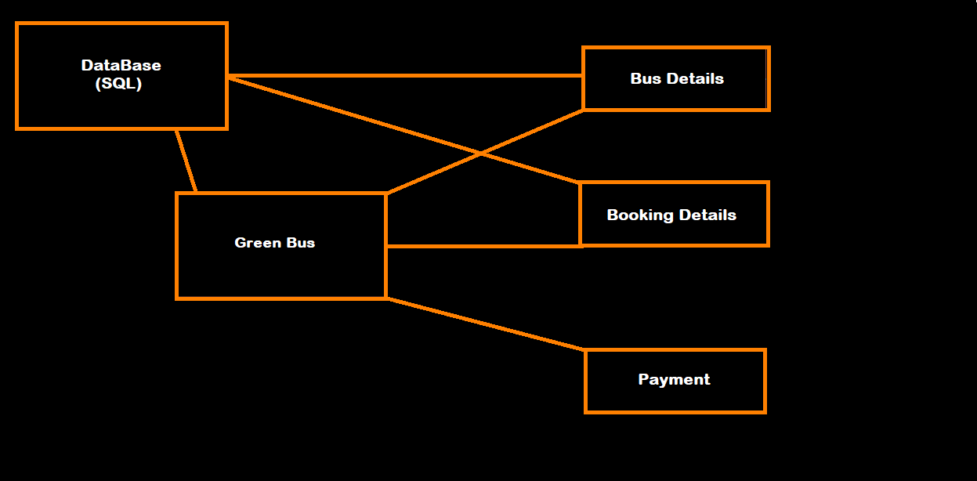

1.12 Standards: -

- Use descriptive and appropriate names for all identifiers (variables, method names, class names, constants, etc.).
- Class names start with an upper case letter. Variable names start with a lower case letter.
- Put a single space before every "{".
- Open braces (i.e. "{") do not start a new line. Close braces (i.e. "}") do start a new line, and are indented with the code they close.
- Avoid the use of the default package.

1.13 Non Functional Requirements:

